1.dream

# Lesson 22 单词讲解

v. 做梦，梦想 (dreamed / dreamt) I always dream of / about flying like a bird.

n. 梦，梦想

I have a dream… = I dreamed a dream

我有一个梦想；坐着一个什么什么梦

-- Martin Luther King

I dreamed a dream in time gone by…

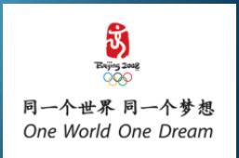

1. dream

v. 做梦，梦想 (dreamed / dreamt) I always dream of / about flying like a bird.

n. 梦，梦想

Your future depends on your dreams. So go to sleep!

1. age n. 年龄，时代

the Ice Age 冰川年代

4 [throw](http://dict.cn/throw.htm) [θrəu] v.扔，抛

1. channel n. 海峡

the Channel

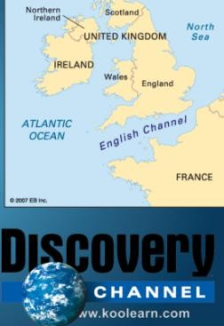the English Channel the British Channel

# Lesson 22 课文&语法讲解

* 1. My daughter, Jane, never dreamed of receiving a letter from a girl of her own age in Holland.
  2. …we were travelling across the Channel and Jane put a piece of paper with her name and address on it into a bottle.

1. …we were travelling across the Channel and Jane put a piece of paper with her name and address on it into a bottle.

with prep.“伴随着有… ／ 和…一起”

with + n. (+介词短语 表示位置)

a purse/wallet with 200 dollars in it a bus with 500 people on it

1. She threw the bottle into the sea. throw threw thrown
2. She never thought of it again... think of …
3. Both girls write to each other regularly now.

5.Letters will cost a little more, but they will certainly travel faster.

修饰比较级

a little (bit) much / a lot / far Even

# Lesson 22 知识拓展

Holland

the Netherlands Dutch

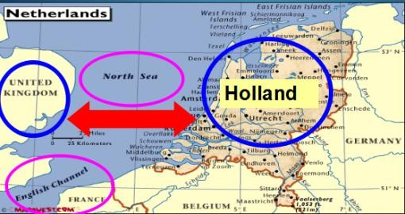

go Dutch (split the bill)

AA制

Dutch courage

酒状怂人胆

If I cheat you, I am a Dutch!